**Имя ___________________________**

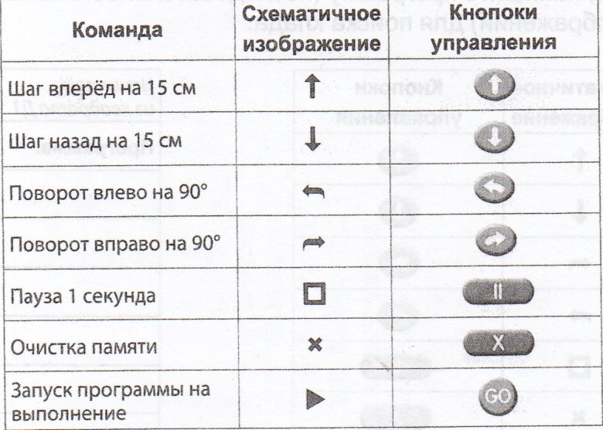

|  |
| --- |
| **Программа:** |
|  |
|  |
|  |
|  |
|  |
|  |
|  |
|  |
|  |
|  |
|  |
|  |
|  |
|  |
|  |
|  |
|  |
|  |
|  |
|  |
|  |
|  |
|  |